1. docker images



1. docker run / docker pull



1. docker ps



1. docker top



1. docker stop / docker start





1. docker rm



1. docker inspect



Docker image – AUFS(AnotherUnion FileSystem)

bootfs (内核，容器组，命名空间，设备映射) / rootfs（基础镜像）/ images… / writable container

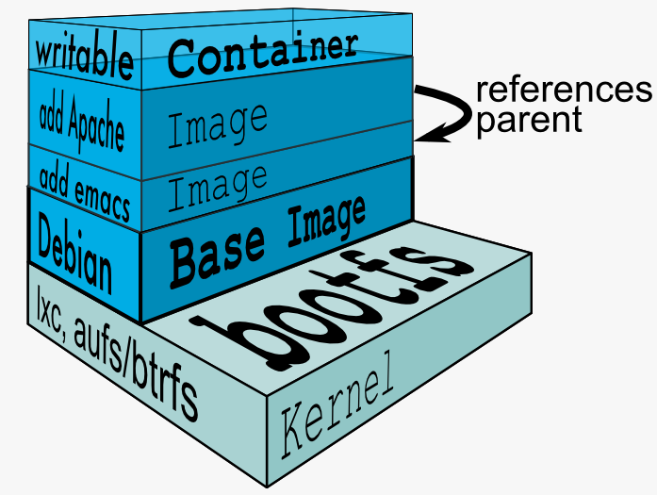

Build a docker image

* docker commit









* docker build









EXPOSE

* -P



* -p



常用的Dockerfile指令：

* EXPOSE
* CMD/ENTRYPOINT
* ENV
* WORKDIR
* USER
* ADD/COPY
* LABEL
* VOLUME

服务编排

1. docker-compose



Start a cluster: docker-compose up –d



Add more brokers: docker-compose scale kafka=3



Destroy a cluster: docker-compose stop

